PQI 380 Interface Board Project

- Transfer Eagle/Pads files to Altium.
- Modify schematics, layout and BOM to make the following modifications
  - Remove R12 and leave open.
  - Modify C10 to connect from R13 to GND.
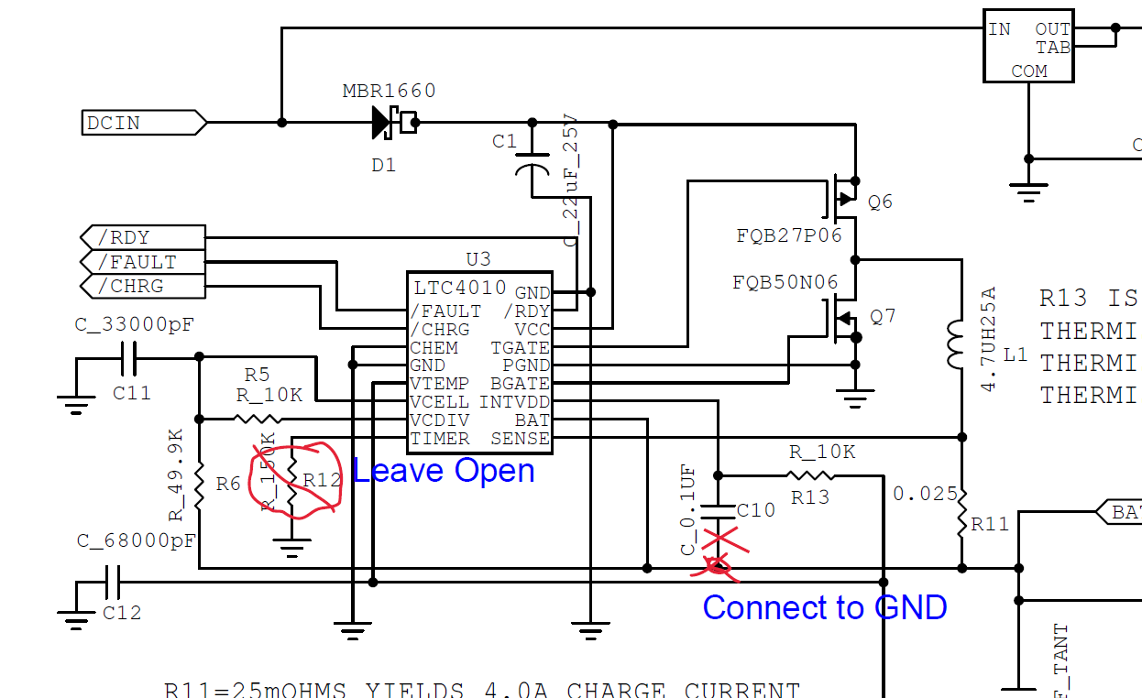
  - Replace C32 with 10uF Tantalum capacitor rated at 35V, such as TCJB106M035R0200.
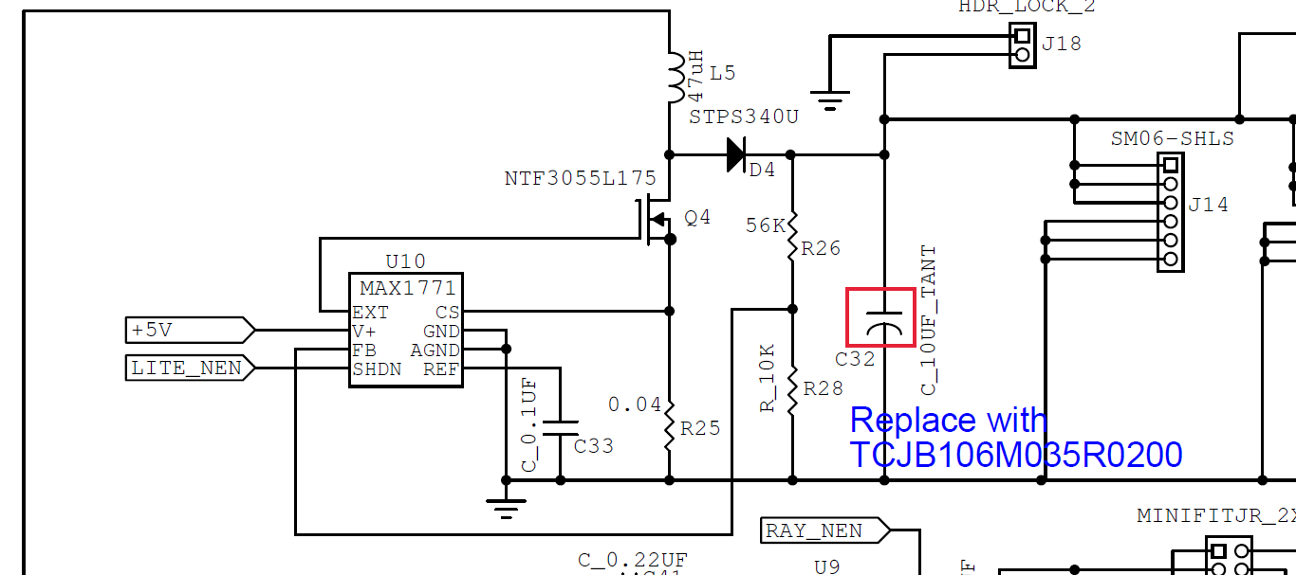
- I am attaching Rev12 schematic in pdf. Please rev to 13. I am also attaching a schematic.
- 7000-0303_Rev12.zip has all the CAD files. Please import them to Altium.
- To help orient you with the layout, I am attaching a rework instruction for manufacturing, to which you are responding with a new design. FN: 7000-0303_r12_c10_mod_032323.pdf

